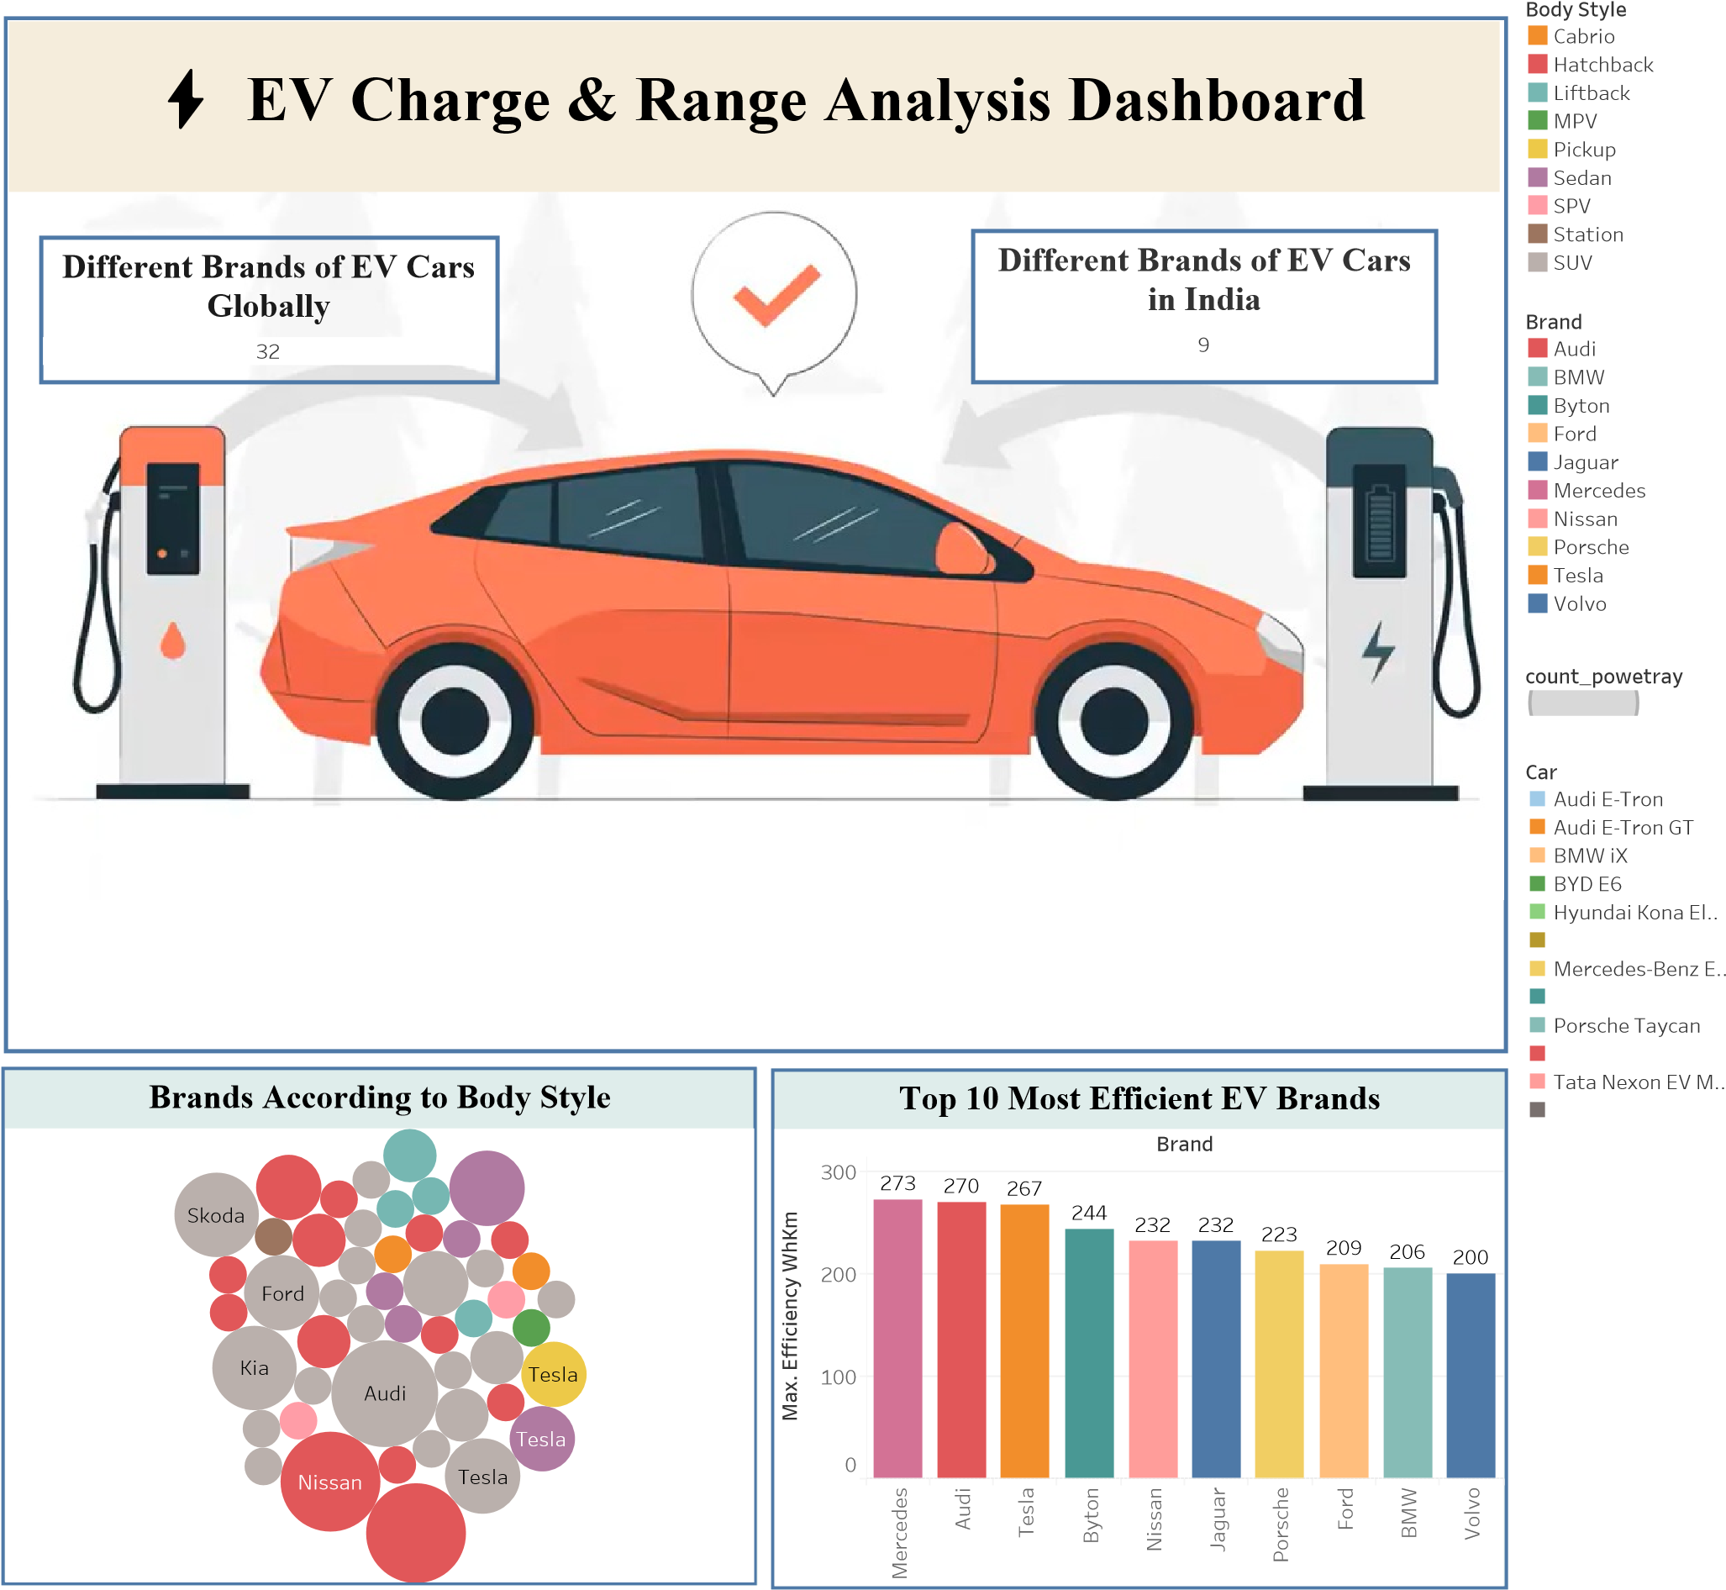
98
Jaguar I-Pace
MG ZS EV
Tata Nexon EV
Tata Tigor EV
Brand filtered by PowerTrain type |  | Different EV Cars in India
8 1  Volkswagen Aiways  1  3  Hyundai  1  Citroen  6  Skoda  1  Sono  Polestar ³  Mercedes |  | Audi E-Tron | BYD E6 | MG ZS EV |  | Porsche Taycan
 |  | Audi E-Tron GT | Hyundai Kona  Electric
 |  |  |  | Tata Nexon EV |  | Tata Tigor EV
 |  | BMW iX | Jaguar I-Pace
 |  |  |  | Tata Nexon EV Max
